

(**ANDROID MEDICARE APPLICATION**)

(Team 18)

(Avatansh Awasthi 1947208

Neil D’Souza 1947217

Prakhar M P 1947250)

**Software Requirements Specification Document**

# **Date: (09/05/2021)**

**Table of Contents**

1. **Introduction**

1.1 Purpose

1.2 Scope

1.3 Overview

**2. The Overall Description**

* 1. Product Perspective
  2. System Interfaces
  3. Hardware Interfaces
  4. Software Interfaces
  5. Memory Constraints
  6. Operations
  7. Product Functions
  8. User Characteristics

2.8.1 Public

2.8.2 Hospitals

2.8.3 Doctors

2.8.4 Medical Stores

* 1. Constraints

1. **Specific Requirements**
   1. External interfaces
   2. Functions
   3. Performance Requirements
   4. Logical Database Requirements
   5. Design Constraints
   6. Software System Attributes
      1. Reliability
      2. Availability
      3. Security
      4. Maintainability
      5. Portability

# **Chapter 1: Introduction**

The application targets the gap that addresses the ease to access and facilitate various medical facilities. The Medicare application targets several unique features that make it different from existing applications in the market. The Medicare application recommends its users various hospitals and medical facilities and specific requirements according to their location and vicinity. The app stores the user data as his/her medical history for further use. The app will let the users book appointments with doctors as and when they require.

If a person is new to a place and they are in urgent need of medical help, then a click would help tend to their needs. Thus, saving time and effort. Ordering medicines from a clinic/pharmacy with proper prescriptions would bring medicines to the doorstep of the customer.

**1.1 Purpose**

The major purpose of this application is to tend to the needs of the general public in ways of booking appointments or contacting doctors who might give an insight or a solution or even a procedure to deal with the condition at the moment. To help users who have gone to another location and are new to the area. This would help them in locating nearby hospitals, clinics in case they need one and have no clue as to where to find them*.*

**1.2 Scope**

The scope of this project is to provide a software-based solution to the customer patients which is able to clearly identify the need of assistance one wants i.e., whether he/she needs to consult with a doctor and book an appointment for the same, or one wants to search for a specific specialty of doctors or hospitals present in their area then we provide with the necessary details accordingly also any kind of medical facility in the locality could be found. Similarly for the doctor’s assistance the customers' clinical history report generator is also included in which the customers history related to his illnesses or diseases or allergies can be kept which in turn will help the doctors to give a personalized suggestion in the treatment of the specific patient.

**1.3 Overview**

This is a working document, such that it is subject to change. In its initial form, it is incomplete by definition, and will require continuous refinement. Requirements may be modified and additional requirements may be added as development progresses and the system description becomes more refined. This information will serve as a framework for the current definition and future evolution of the Medicare app.

# **Chapter 2: The Overall Description**

The ability to access the locations of the hospitals or clinics nearby, or be it contacting a doctor or booking an appointment with a specialist doctor will be possible through the application. In order to access the resources of the application, a person will have to create an account and then use the resources available to them. They will be given the freedom to add their medical records and history to the app so that it would be easier for doctors to view their medical history and suggest treatment accordingly.

**2.1 Product Perspective**

The product is a mobile application which is aiming for an easier and portable healthcare system for the user. The system is going to suggest nearby hospitals and medical stores using google maps API. User needs to login in and feed some details initially, and the app will suggest accordingly.

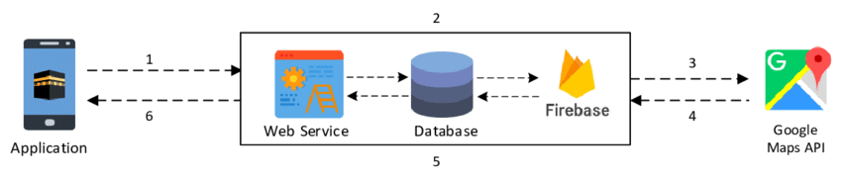

Fig 2.1 : Product Perspective

The system will be focusing on users’ present location and their specific requirements. The application will connect with the webservice, which will go through the Firebase database and connect to Google maps API, and will return the request to the user as shown in the diagram above. The database will be storing users’ data and also the previous searches and appointments booked.

**2.2 System Interfaces**

* A login page where users have to give their credentials and log in to the main system.
* Forget password, in case the user needs help regarding login authentication.
* A welcome page on successful login, which is going to be the landing page of the app, from where the user can navigate other features and facilities.
* An appointment booking, where users can search for available appointments and book for the required appointments, in the navigation bar of the app.
* A button which will enable the user to search for the nearby hospitals or medical stores.
* An emergency button which will automatically call/inform the nearest hospital in case of accident.
* In the navigation bar, there is an option to update the medical records of the user.
* Special login page for hospitals, doctors and medical stores so that the app can connect them to users easily.
* Logout button.

**2.3 Hardware Interfaces**

* Processor - ARMv7 200 MHz processor or newer versions.
* Storage - 32MB Minimum
* RAM - Minimum of 32MB or above.

**2.4 Software Interfaces**

* Operating system - Android 4.4, or above.
* Database - Firebase
* Front End - XML
* Back End - Java / Kotlin
* Development Platform - Android Studio

**2.5 Memory Constraints**

Memory constraints will come into play when the size of the database grows to a considerable size.

**2.6 Operations**

The operations required by the user such as:

1. Nearby hospital and medical store recommendation.
2. Booking of appointments
3. Emergency button
4. Add or update medical records of the user.

**2.7 Product Functions**

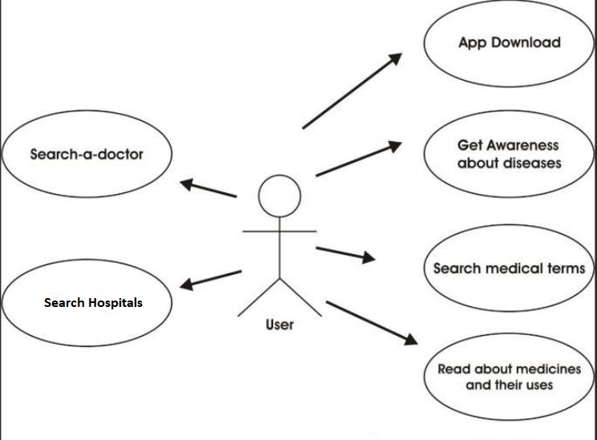

Fig 2.2 : Product Functions

**2.8 User Characteristics**

Following are the user characteristics of the product being developed.

**2.8.1 Public**

Users that are going to login in the system, store their medical records and use the various features of the app.

**2.8.2 Hospitals**

Even though it is not actually necessary, hospitals can use the app, will have special login and can help in connecting and facilitating users with their services.

**2.8.3 Doctors**

Similar to hospitals, doctors can also register on the app with special login to connect with users easily.

**2.8.4. Medical Stores**

Similar to hospitals and doctors, medical stores can have special login so that they can provide service to users easily.

**2.9 Constraints**

Listed below are the constraints for the system –

* The emergency button can be upgraded in such a way that it can use the sensors like accelerometer, gravity, gyroscope to predict an accident and call the nearest hospital automatically. However, the exception to this is a lot in numbers, in cases such as a user casually throwing his phone on bed, jumping while having phone in pocket and so on. It is not actually possible to work on this feature.
* The app needs internet connection and will not be able to function offline as both the Firebase and Google Maps API need internet connection.
* Users need to connect with hospitals, doctors and medical stores (which are not registered on the app) manually.

# **Chapter 3:Specific Requirements**

The system needs to do the following:

* + Login for users and special login for hospitals, doctors and medical stores
  + Database containing - user login credential, user medical records and previous searches; details of hospitals, doctors and medical stores
  + Able to connect with hospitals and doctors to book appointments
  + Emergency button to call nearest hospital
  + Recommend specified hospitals, doctors and medical stores available near to the user using Google Maps API
  + Show user records to hospitals, doctors and medical stores when they have registered.
  + User and hospitals, doctors and medical stores communication
  + Needs to be as user friendly as possible.

### **3.1 External Interfaces**

Although the android-based application does not need any external hardware to connect with, it does need some external interfaces as users have to connect with the hospitals, doctors and medical stores near to them.

In case, the hospitals, doctors and medical stores have not registered them on the app, users need to connect with them manually and thus external interfaces are required.

Some of the external interfaces are listed below:

* Call - to connect with hospitals, doctors and medical stores
* Text Messenger - to send or receive message to/from hospitals, doctors and medical stores
* Email - to contact hospitals, doctors and medical stores, usually email responses are slow.
* Google Maps - to locate nearby hospitals, doctors and medical stores as per the requirement.

### **3.2 Functions**

Functions in the application include:

* Validity checks on the login
* Assist users in case of forgotten password
* Connect automatically to nearest hospitals in case of emergency
* Search for hospitals, doctors and medical store
* Connect with hospitals, doctors and medical store
* Able to fetch user information such as medical history from database for the hospitals, doctors and medical store

### **3.3 Performance Requirements**

* 1. The performance of environmental control will be always proportional to the network speed available and the throughput will be at maximum if the network speed will be at megabits per second. For experiencing better performance of the system, we need to have a good internet facility and uninterrupted resource for accessing the application. The real-world business-to-business sales data set used is publicly available. Also, connecting with hospitals, doctors and medical stores can be an issue at times.

### **3.4 Logical Database Requirements**

The database is required to do the followings -

* Store user login credential
* Store user medical records
* Store details of hospitals, doctors and medical stores
* Fetch details of patients for the hospitals, doctors and medical stores

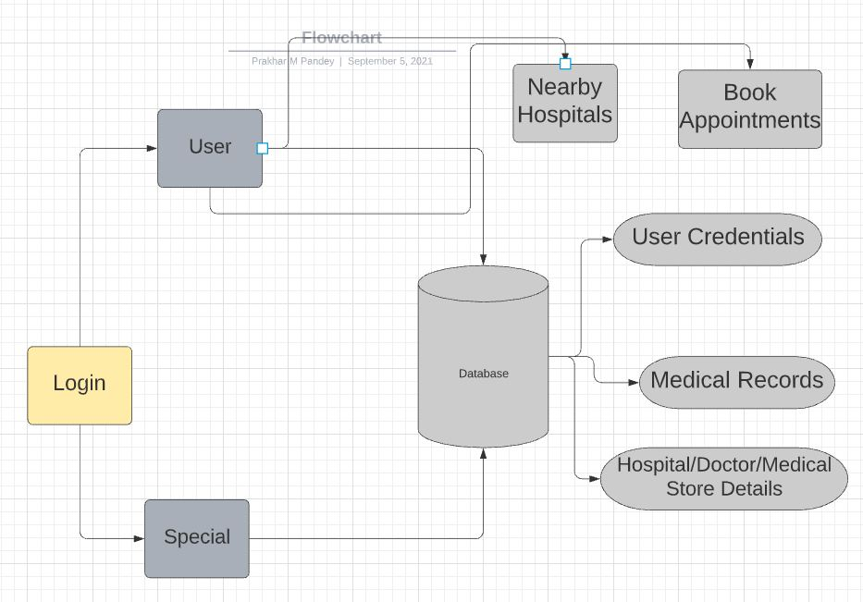

Fig 3.1 : Logical Database.

### **3.5 Design Constraints**

The UI is simple and user-friendly, the application is specifically designed for mobile devices, so there are not many constraints in the design part. Some older devices might face some design issues.

### **3.6 Software System Attribute**

Following are the system attributes of the product being developed.

### **3.1 Reliability**

This application becomes more and more reliable as more hospitals, doctors and medical stores start using and getting registered on the application. That way users don’t have to connect with them manually.

**3.2 Availability**

Mobile based applications need a charged battery and internet connection to function.

### **3.3 Security**

Use of hash function can also increase security greatly. The application will also be secured with authentication.

### **3.4 Maintainability**

The initial establishment cost will be high. But the maintenance cost will be less once setup, afterwards maintenance cost is less. Only needs small updates from time to time in order to keep up with the newer OS versions.

### **3.5 Portability**

Mobile devices are very common and very portable. The application here is like a hospital walking along with the user. High portability, however, internet connection is required all the time for the application to work.